DDR3L for every need: U-DIMM/VLP, U-DIMM/R-DIMM/VLP, R-DIMM/SO-DIMM
Premier Series DDR3L memory modules offer multiple form factors for various installation needs. All run at a reduced 1.35V compared to 1.5V on standard DDR3, with speeds up to 1600MHz. Whether in standard U-DIMM, very low profile modules (VLP), or small outline modules (SO-DIMM) for notebooks, all implement cutting edge technology that enables remarkable memory quality, stability, and reliability. All modules are produced in accordance with JEDEC and RoHS design and production standards, guaranteeing compatibility with every major computing platform. Each is also made with environmental protection and preservation in mind, and includes a lifetime ADATA warranty.
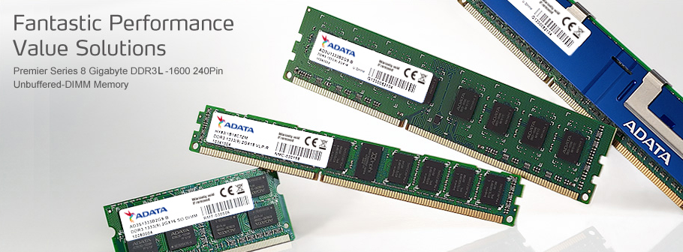
Features | U-DIMM  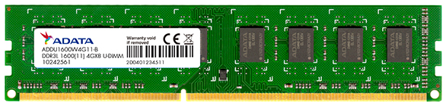  VLP U-DIMM  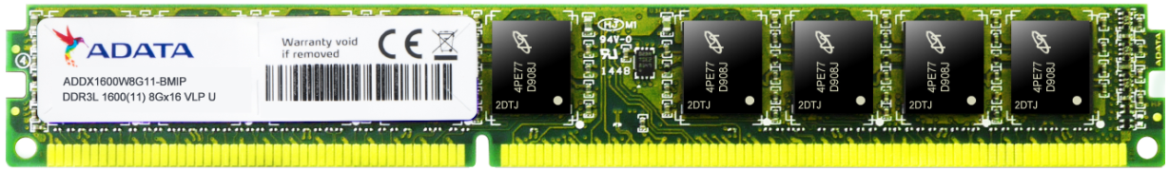  R-DIMM  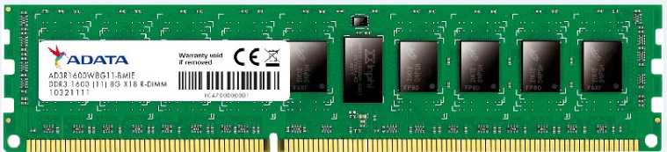  VLP R-DIMM  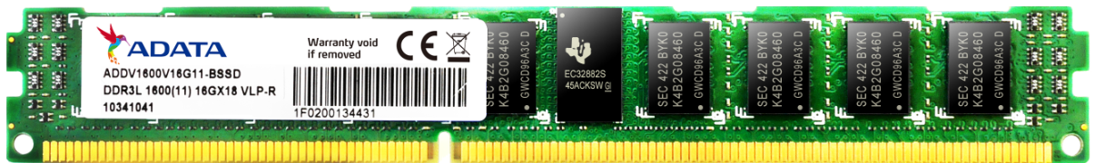  SO-DIMM  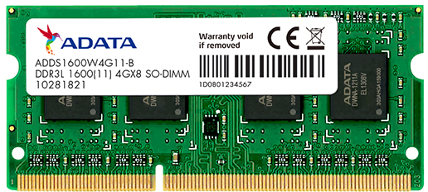
- High speed up to 1600MHz
- Transfer bandwidths up to 12.8GB/s
- Energy efficient: save up to 10% compared to DDR3
- 6-layer PCB provides improved signal transfer and system stability
Specifications
Type | U-DIMM | VLP U-DIMM | R-DIMM | VLP R-DIMM | SO-DIMM
Form factor | Standard  (1.18" height) | Standard  (0.7" height) | Standard  (1.18" height) | Very low profile (0.7" height) | Standard  (1.18" height)
Suitable for | Desktop | Desktop / Thin client | Enterprise servers / data centers | Blade servers | Notebook
Interface | 240-pin | 240-pin | 240-pin | 240-pin | 204-pin
Capacity | 2GB/4GB/8GB | 4GB/8GB | 4GB/8GB/16GB | 4GB/8GB | 2GB/8GB
Rank | Single / Dual | Single / Dual | Single / Dual | Single / Dual | Single / Dual
Speed | Up to 1600MHz
VDD voltage | 1.35V
CAS latency | CL11
Refresh | Auto-refresh / self-refresh
Operating temperature | 0°C-85°C
RoHS | Yes
Standard | JEDEC
Warranty | Limited lifetime warranty
Ordering Information
Product | Capacity | Rank | Voltage | Data rate | Speed | CL | Part number
U-DIMM | 2GB | Single | 1.35V | 1600MT/s | PC3L-12800 | CL = 11 | ADDU160022G11
U-DIMM | 4GB | Single | 1.35V | 1600MT/s | PC3L-12800 | CL = 11 | ADDU1600W4G11
U-DIMM | 8GB | Dual | 1.35V | 1600MT/s | PC3L-12800 | CL = 11 | ADDU1600W8G11
VLP U-DIMM | 4GB | Single | 1.35V | 1600MT/s | PC3L-12800 | CL = 11 | ADDX1600W4G11
VLP U-DIMM | 8GB | Dual | 1.35V | 1600MT/s | PC3L-12800 | CL = 11 | ADDX1600W8G11
R-DIMM | 4GB | Single | 1.35V | 1600MT/s | PC3L-12800 | CL = 11 | ADDR1600W4G11
R-DIMM | 8GB | Dual | 1.35V | 1600MT/s | PC3L-12800 | CL = 11 | ADDR1600W8G11
R-DIMM | 16GB | Dual | 1.35V | 1600MT/s | PC3L-12800 | CL = 11 | ADDR1600Y16G11
VLP R-DIMM | 4GB | Single | 1.35V | 1600MT/s | PC3L-12800 | CL = 11 | ADDV1600W4G11
VLP R-DIMM | 8GB | Dual | 1.35V | 1600MT/s | PC3L-12800 | CL = 11 | ADDV1600W8G11
SO-DIMM | 2GB | Single | 1.35V | 1600MT/s | PC3L-12800 | CL = 11 | ADDS160022G11
SO-DIMM | 8GB | Dual | 1.35V | 1600MT/s | PC3L-12800 | CL = 11 | ADDS1600W8G11

